We are excited that you will be representing the City of St. Petersburg in our Sister City **Takamatsu, Japan**, this summer. This is a big commitment from you, your family, SPIFFS, and the City. It also can be a life changing opportunity.

SPIFFS wants to make sure that you are prepared. We are creating this guide to help you throughout the process. We will have it online on our website so it can be updated, shared, corrected, and read from anywhere.

Did you know that there is a Takamatsu Sister City mural in downtown St. Pete? It is in the alley between Central Ave. and 1st Ave N., on the west side.

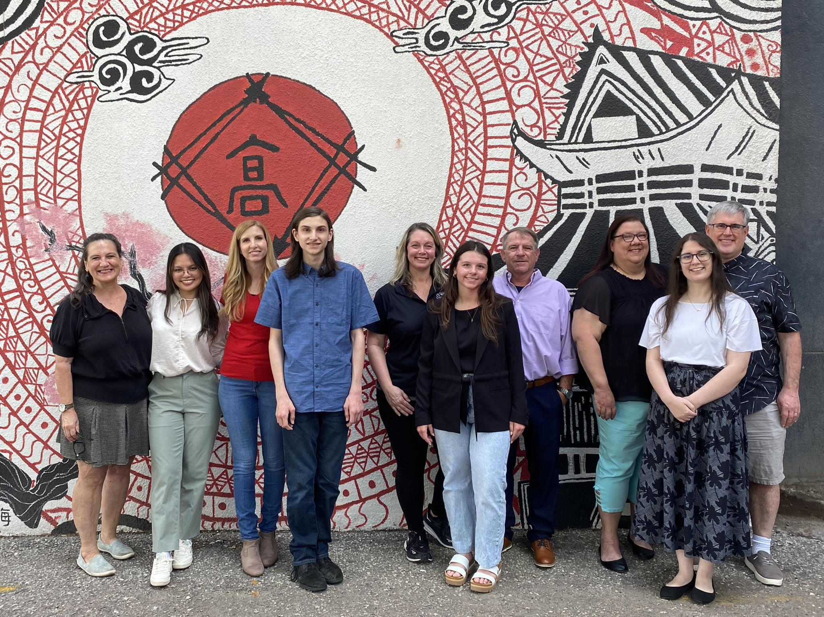

2024 Student Ambassadors & Families

We will have a photo shoot with you and your families in front of it too. Over the next two months, we will get together several times. Sometimes with everyone, sometimes with just the students. SPIFFS will provide you with some Japanese language and etiquette lessons. Former ambassadors and their families will help you with questions and concerns about travel.

***Technology:***

We use [Whatsapp](https://www.whatsapp.com/) to communicate when you are abroad.

We use [Slack](https://takamatsusist-xv08157.slack.com/archives/C08PU3H13FY) to communicate as a team throughout the whole program.

This guide will be on SPIFFS.org in the [Sister Cities](https://www.spiffs.org/st-petersburgsistercities) tab.

You can find SPIFFS’ social media: [IG](https://www.instagram.com/spiffsfl/) * [FB](https://www.facebook.com/spiffsfolkfair) * [Tik Tok](https://www.facebook.com/StPeteFL)

You can find St. Pete’s social media: [IG](https://www.instagram.com/stpetefl/) * [FB](https://www.facebook.com/StPeteFL)

***Dates:***

Exact Dates are still being determined. These are general:

Travel to Takamatsu: July 6-17, 2025

Japanese Students’ visit: August 3-14, 2025

Welcoming Party

Photo shoot

Student get togethers:

Family get togethers:

Other dates will include Welcome Dinner for Japanese group; Japanese students’ presentations to St. Pete City Council, Mayor, & Chamber of Commerce; Farewell Dinner for Japanese Group; St. Pete students’ presentations to St. Pete City Council.

**Sister Cities - St. Petersburg & Takamatsu**

St. Pete and Takamatsu’s Sister City roots began in 1959, when the Takamatsu General Assembly decided they wanted Sister Cities. St. Petersburg and Takamatsu became official on October 5, 1961.

The two cities share many characteristics. Both are coastal, but not oceanic. Both have hot, humid summers, though Takamatsu gets more rain. Takamatsu is the bigger city, in both population and area. Both cities have colleges and universities. Takamatsu officially became a city in 1890, and St. Petersburg incorporated in 1892. Takamatsu is in Kagawa Prefecture (a prefecture is similar in function to a state in the US).

The relationship between the two cities have brought art, sports, business, and cultural activities to St. Petersburg. Baseball teams, families, teachers, and of course student ambassadors have been traveling between the two cities for more than 60 years.

**Student Ambassadors Traveling to Japan**

Our students heading to Japan usually (though not always) stay with the family who is sending a student ambassador to St. Pete. Students bring gifts to their host families, and are given an official gift from the City of St. Petersburg to present to Takamatsu’s Mayor and City Council. 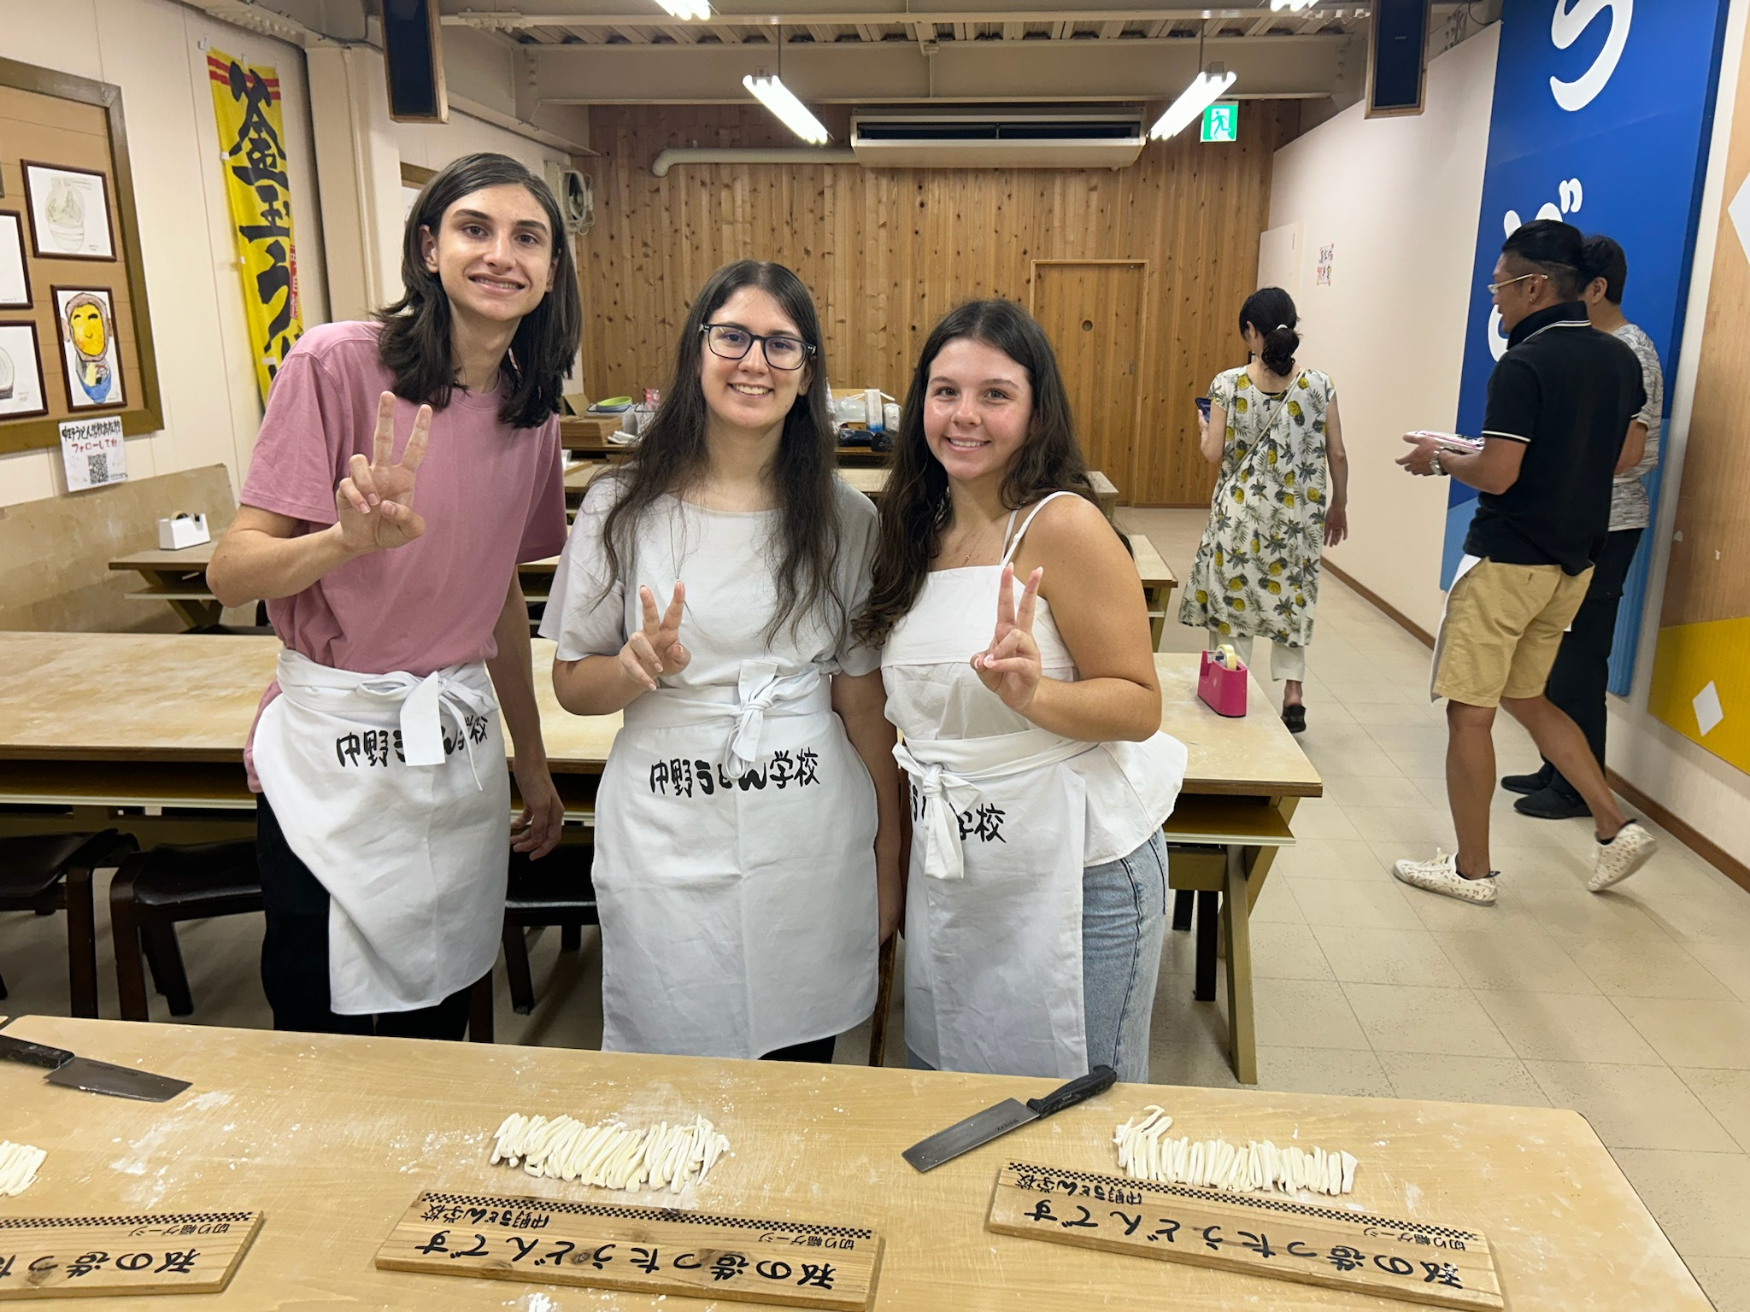

Prior to going, there will be several times SPIFFS will work with the students and families to help with Japanese etiquette, language, and general cultural awareness. Each student will do a presentation to the Takamatsu City Council. We will help you work through those. Our Japanese counterparts provide an interpreter for all of the official events.

Students will also be attending a day and a half of school in Takamatsu. The first half day is similar to our field days - please make sure you pack for it. The second (full) day you will be in class all day. The uniform is a basic white shirt and black pants/skirt.

We are lucky to have our families from last year interested in being involved in this year’s exchange. These students and families are invaluable as a resource. We will have information about the family and Japanese student ambassadors before you go, and will work on proper pronunciation and greetings for you.

SPIFFS arranges for the flights, travel insurance, and travel medical insurance. Please make sure your passport is current. Please make sure if you take medications, you have an updated prescription. Do not hesitate to let us know of any medical or any other condition that might need special attention. We want to make sure everything is prepared so your trip is fantastic.

Our students do a presentation to the St. Petersburg City Council a few weeks after the Japanese students leave. This presentation can be about what you learned in Takamatsu and what you did while you were there. It also gives you a chance to tell the council how you showed off St. Petersburg to their ambassadors. You will get guidance on the structure of the presentation.

**Japanese Student Ambassadors Stay in St. Petersburg**

We will give everybody information about the Japanese students as soon as we get it. They pick their students about a month after we pick ours. Everyone goes to greet the Japanese students and their chaperone at the airport. Their chaperone is possibly staying for about half of the visit this year. We don’t plan anything for the arrival day. But after that, buckle up!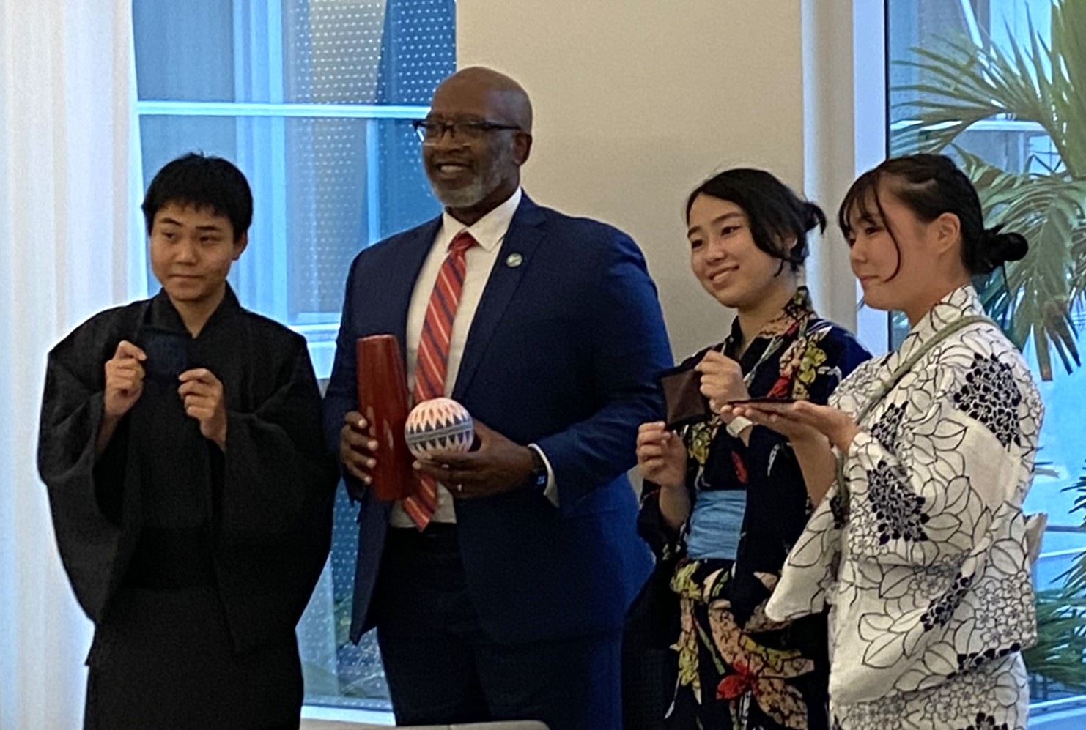

Hosting a Japanese student is just like hosting any other guest, except you might have to be more insistent on their comfort. The Japanese have a very polite culture, so keep in mind they will *always* tell you that everything is fine.

It would be great if they could have their own room, which may not always be possible. As long as they have some privacy, everything will work out. You will be having some meals together, and there will be planned meals and activities throughout the visit. The Japanese students are often interested in seeing American supermarkets and stores - Trader Joe’s and Targets are adventures for them, just as the markets of Takamatsu will be for our students.

Families provide transportation for the students, and occasionally for the chaperone. There are official activities with the City - a welcome dinner; Japanese students’ presentation to City Council (currently scheduled for August 7th, time TBA); Rowdies game - Rays game is a maybe; Sunken Gardens, museums, and other cultural visits.

Last year each family hosted a night for everyone. These aren’t fancy - a pool party, or pizza making party, game night - something that is typical for an American family to do. There are free nights built into the students’ schedules, though there is a planned event every day. We also find out what the Japanese students are interested in doing.

We will ask you to adapt the letters you wrote in the application to the host families to more specifically reflect not only your student’s visit to Japan, but their student’s visit to St. Pete. This will be a great way for them to anticipate some of what they will see when they come to visit.

Thank you once again for being part of this wonderful and historic program. We want to introduce you to the personnel who you will be working with throughout the program. The City of St. Petersburg engages SPIFFS to manage the Sister City Program. We also have a Sister City in Isla Mujeres, Mexico.

**SPIFFS**

JoEllen Schilke, SPIFFS Executive Director

Steven Barefield, SPIFFS Board President (fluent in Japanese)

Tanner Landsdale, SPIFFS Board member, Sister Cities (fluent in Japanese)

**City of St. Petersburg**

Celeste Davis, Director of Arts, Culture and Tourism

David Thompson, Director of Government Affairs